You are given a nested list of integers nestedList. Each element is either an integer or a list whose elements may also be integers or other lists.

The **depth** of an integer is the number of lists that it is inside of. For example, the nested list [1,[2,2],[[3],2],1] has each integer's value set to its **depth**.

Return *the sum of each integer in* nestedList *multiplied by its* ***depth***.

**Example 1:**

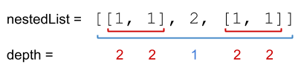

Input: nestedList = [[1,1],2,[1,1]]  
Output: 10  
Explanation: Four 1's at depth 2, one 2 at depth 1. 1*2 + 1*2 + 2*1 + 1*2 + 1*2 = 10.

**Example 2:**

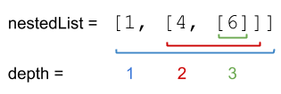

Input: nestedList = [1,[4,[6]]]  
Output: 27  
Explanation: One 1 at depth 1, one 4 at depth 2, and one 6 at depth 3. 1*1 + 4*2 + 6*3 = 27.

**Example 3:**

Input: nestedList = [0]  
Output: 0

**Constraints:**

* 1 <= nestedList.length <= 50
* The values of the integers in the nested list is in the range [-100, 100].
* The maximum **depth** of any integer is less than or equal to 50.